ANNUAL EXAM [2023 – 24]
Class-IX(Mathematics) Date: 20/02/2024 Time: 3 hrs. MM: 80
General Instructions:
- This Question Paper has 5 Sections A-E.
- Section A has 20 MCQs carrying 1 mark each
- Section B has 5 questions carrying 02 marks each.
- Section C has 6 questions carrying 03 marks each.
- Section D has 4 questions carrying 05 marks each.
- Section E has 3 case based integrated units of assessment (04 marks each) with subparts of the values of 1, 1 and 2 marks each respectively.
- All Questions are compulsory. However, an internal choice in 2 Qs of 5 marks, 2 Qs of 3 marks and 2 Questions of 2 marks has been provided. An internal choice has been provided in the 2 marks questions of Section E.
- Draw neat figures wherever required. Take π =22/7 wherever required if not stated.
SECTION-A (1x20=20)
- Multiple Choice Questions:-
1. (125)^{-1/3} = ?
A. 5 B. -5 C. $\frac{1}{5}$ D. $\frac{-1}{5}$
2. If $\sqrt{2}$ = 1.414, then $\frac{1}{\sqrt{2}}$ = ?
A. 0.075 B. 0.75 C. $0.705$ D. 7.05
3. Degree of the zero polynomial is
A. 1 B. 0 C. not defined D. none of these
4. The zeroes of the polynomial p(x) = 2x² + 5x - 3 are
A. $\frac{1}{2}, 3$ B. $\frac{1}{2}, -3$ C. $\frac{-1}{2}, 3$ D. $1 ,\frac{-1}{2}$
5. The measure of the angle is five times its complement. The angle
measures
A. 25⁰ B. 35⁰ C. 65⁰ D. 75⁰
6. In the given figure, AOB is a straight line. If
$$∠AOC=4x° and ∠BOC=5x°, then ∠AOC=?$$
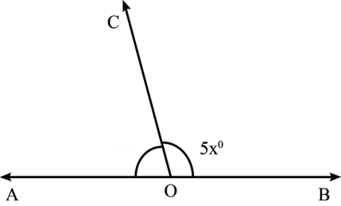
7. The graph of the line x = 3 passes through the point
A. (0, 3) B. (2, 3) C. (3, 2) D. None of these
8. A linear equation in two variables x and y is of the form ax + by + c = 0 where
A. a $≠0, b≠0$ B. a $≠0, b=0$ C. a $=0, b≠0$ D. a $=0, b=0$
9. The point C(-6, 0) lies
A. in quadrant II B. in quadrant III C. On the x - axis D. On the y - axis
10. Three angles of a quadrilateral are in the ratio 80⁰, 95⁰and 112⁰. Its fourth angle is
A. 78⁰ B. 73⁰ C. 85⁰ D. 100⁰
11. If an angle of a parallelogram is two - third of its adjacent angle, the smallest angle of the parallelogram is
A. 108⁰ B. 54⁰ C. 72⁰ D. 81⁰
12. The angle in a semicircle measures
A. 45⁰ B. 60⁰ C. 90⁰ D. 36⁰
13 In the figure, if ∠ACB = 50°, then ∠OAB is
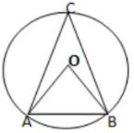
(a) 50° (b) 40° (c) 90° (d) 100°
14. Each of the two equal sides of an isosceles right triangle is 10cm long. Its area is
A. 5$\sqrt{10}$cm² B. 50cm² C. 10$\sqrt{3}$cm² D. 75cm²
15. In a $∆ABC$ it is given that base = 12cm and height = 5cm. Its area is
A. 60cm² B. 30cm² C. 15$\sqrt{3}$cm² D. 45cm²
16. The height of a cone is 21 cm and its slant height is 28 cm. The volume of the cone is
A. 7356cm³ B. 7546cm³ C. 7506cm³ D. 7564cm³
17. The surface area of a sphere of radius 21 cm is
A. 2772 cm² B. 1386 cm² C. 4158cm² D. 5544cm²
18. If the mean of five observation x, x+2, x+4, x+6 and x+8 is 11, then the value of x is
A. 5 B. 6 C. 7 D. 8
Directions: In the following questions as Assertion (A) is given followed by a Reason (R). Mark your responses from the following options.
(A) Both Assertion and Reason are true and Reason is the correct explanation of ‘Assertion’
(B) Both Assertion and Reason are true and Reason is not the correct explanation of ‘Assertion’.
(C) Assertion is true but Reason is false
(D) Assertion is false but Reason is true
19. Assertion: the side of equilateral triangle is 6 cm then the area of triangle is 9 √3 cm².
Reason: All the side of equilateral triangle are equal.
20. Assertion: √5 is an Irrational Number.
Reason: A Number is called Irrational if it cannot be written in the p/q form. where p and q both are integers and q ≠ 0.
SECTION-B (5x2=10)
21. Simplify (3 + $\sqrt{3}$) . ${(2 + \sqrt{2})}^{2}$
OR
$$\frac{\sqrt{72}}{5 \sqrt{72}+ 3\sqrt{288}- 2\sqrt{648}}$$
22. Rationalize the denominator $\frac{3 - 2\sqrt{2}}{3+ 2\sqrt{2}}$
23. Find the value of polynomial p(x) = x² - 2$\sqrt{x}+ 1$ at x=4
24. Show that x = 3 and y = 2 is a solution of the linear equation
2x + 3y = 12
25. A chord of length 16cm is drawn in a circle of radius 10cm. Find the distance of the chord from the centre of the circle.
OR
Prove that equal chords of a circle subtend equal angles at the centre.
SECTION-C (6x3=18)
26. i. Express the following 0.235235.... into p/q form, where p & q are integers and q ≠0.
ii. Find Four Rational Number between 3/5 and 4/7.
27. Find the remainder when the polynomial P(x) = 4x³ – 12x² + 14x – 3 is divided by g(x) = (2x-1)
28. The three vertices of a $∆ABC$are A (1,4), B (-2,2) and C (3,2). Plot these point on a graph paper and calculate the area of $∆ABC$
29. Write any 3 Euclid’s Axioms.
30. Three girls, Reshma, Salma and Mandip, are playing a game by standing on a circle of radius 5m drawn in a park. Reshma throws a ball to Salma, Salma to Mandip, and Mandip to Reshma. If the distance between Reshma and Salma and between Salma and Mandip is 6m each, what is the distance between Reshma and Mandip?
OR
If the non-parallel sides of a trapezium are equal, prove that it is cyclic.
31. ABCD is a quadrilateral in which AD = BC and ∠DAB = ∠CBA .Prove that
(i) ΔABD ≅ ΔBAC
(ii) BD = AC
(iii) ∠ABD = ∠BAC.
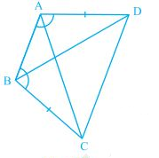
SECTION-D (4x5=20)
32. The length of 62 leaves of a plant are measured in milliliters and the data is represented in the following table
Length in mm | 118 - 126 | 127 - 135 | 136 - 144 | 145 - 153 | 154 - 162 | 163 - 171 | 172 - 180
No. of leaves | 8 | 10 | 12 | 17 | 7 | 5 | 3
Draw a histograph to represent the above given data.
33. Prove that the diagonals of a square are equal and bisect each other at right angles.
OR
ABCD is a rhombus and P, Q, R and S are the mid-points of the sides AB, BC, CD and DA respectively. Show that the quadrilateral PQRS is a rectangle.
34. Expand the following
(a) (4a - b + 2c)² (b) (4 - $\frac{1}{3x}$)³
35. A corn cob shaped somewhat like a cone, has the radius of its broadest end as 2.1 cm and length as 20 cm. If each 1 sq cm of the surface of the cob carries an average of four grains, find how many grains you would find on the entire cob [Approximately]?
OR
A shot - put is a metallic sphere of radius 4.9 cm. If the density of metal is 7.8 g per cm³, Find the mass of the shot - put.
SECTION-E (3x4=12)
Q-36 CASE STUDY-1
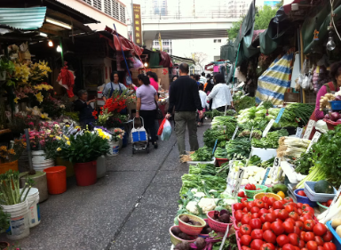
Anil went to buy some vegetables, he bought ‘x’ kgs. of tomato and ‘y’ kgs. of potato. The total cost of vegetables comes out to be of Rs. 200. Now if the cost of 1 kg of tomato is Rs. 50 and 1 kg of potato is Rs. 20, then answer the following questions.
(i) Write an equation to represent the above case.
(ii) If Anil bought ‘x’ kgs of tomato and 2.5 kgs. of potato, then find the value of ‘x’.
(iii) If Anil bought ‘2’ kgs of tomato and ‘y’ kgs of potato, then find the value of ‘y
Q-37 CASE STUDY-2
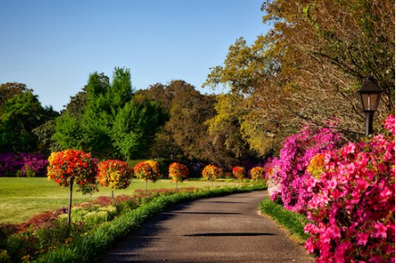
In a park, there are two triangular flower beds. Flower bed ABC has sides AB = 8 cm, BC = 6 cm, and CA = 10 cm. Flower bed PQR has sides PQ = 8 cm, QR = 10 cm, and RP = 6 cm.
(i) Using the given information, can we conclude that flower bed ABC is congruent to flower bed PQR?
(ii) If angle A = 40° and angle B = 60° in flower bed ABC, what is the measure of angle C?
(iii) In flower bed ABC, a new side AD is added such that AD = 8 cm. Now, can we conclude that triangle ABD is congruent to triangle PQR?
38. CASE STUDY-3
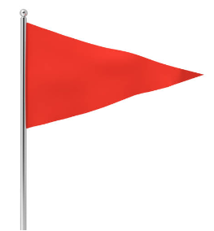
While selling clothes for making flags, a shopkeeper claims to sell each piece of cloth in the shape of an equilateral triangle of each side 10 cm while actually he was selling the same in the shape of an isosceles triangle with sides 10 cm, 10 cm and 8 cm.
- If the shopkeeper sells 500 equilateral triangular flags, then find its area.
- What is the semi-perimeter of an isosceles triangular flag.
- Find the area of an isosceles triangular flag using Heron’s formula

